Getting Started

Installation
You can download the latest version of Bootstrap Toggle or use CDN to load the library.
Warning If you are using Bootstrap v2.3.2, use bootstrap2-toggle.min.js and bootstrap2-toggle.min.css instead.
<link href="https://gitcdn.github.io/bootstrap-toggle/2.2.2/css/bootstrap-toggle.min.css" rel="stylesheet"> <script src="https://gitcdn.github.io/bootstrap-toggle/2.2.2/js/bootstrap-toggle.min.js"></script>

Bower Install
bower install bootstrap-toggle

Usage

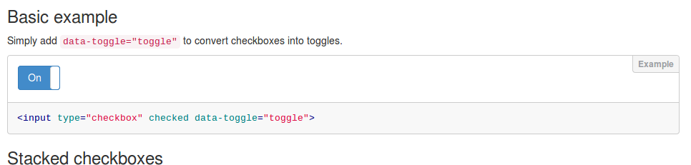

Basic example
Simply add data-toggle="toggle" to convert checkboxes into toggles.
<input type="checkbox" checked data-toggle="toggle">

Stacked checkboxes
Refer to Bootstrap Form Controls documentation to create stacked checkboxes. Simply add data-toggle="toggle" to convert checkboxes into toggles.

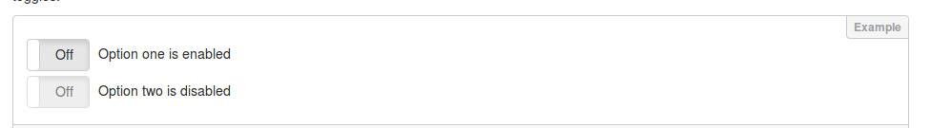
<div class="checkbox"> <label> <input type="checkbox" data-toggle="toggle"> Option one is enabled </label> </div> <div class="checkbox disabled"> <label> <input type="checkbox" disabled data-toggle="toggle"> Option two is disabled </label> </div>

Inline Checkboxes
Refer to Bootstrap Form Controls documentation to create inline checkboxes. Simply add data-toggle="toggle" to a convert checkboxes into toggles.
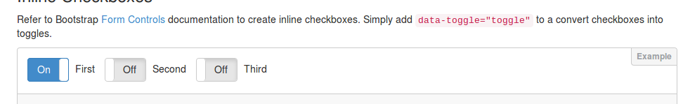
<label class="checkbox-inline"> <input type="checkbox" checked data-toggle="toggle"> First </label> <label class="checkbox-inline"> <input type="checkbox" data-toggle="toggle"> Second </label> <label class="checkbox-inline"> <input type="checkbox" data-toggle="toggle"> Third </label>

API

Initialize by JavaScript
Initialize toggles with id toggle-one with a single line of JavaScript.
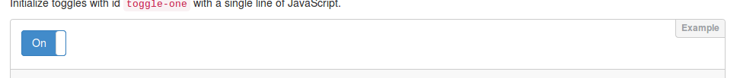
<input id="toggle-one" checked type="checkbox"> <script> $(function() { $('#toggle-one').bootstrapToggle(); }) </script>

Options
Options can be passed via data attributes or JavaScript. For data attributes, append the option name to data-, as in data-on="Enabled".

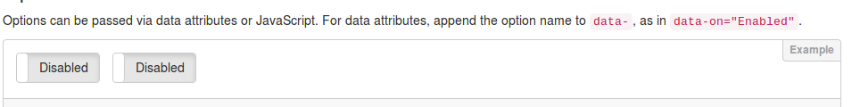
<input type="checkbox" data-toggle="toggle" data-on="Enabled" data-off="Disabled"> <input type="checkbox" id="toggle-two"> <script> $(function() { $('#toggle-two').bootstrapToggle({ on: 'Enabled', off: 'Disabled' }); }) </script>
Name | Type | Default | Description
on | string | html | "On" | Text of the on toggle
off | string | html | "Off" | Text of the off toggle
size | string | "normal" | Size of the toggle. Possible values are:large,normal,small,mini  Refer to Bootstrap Button Sizes documentation for more information.
onstyle | string | "primary" | Style of the on toggle.  Possible values are:default,primary,success,info,warning,danger  Refer to Bootstrap Button Options documentation for more information.
offstyle | string | "default" | Style of the off toggle.  Possible values are:default,primary,success,info,warning,danger  Refer to Bootstrap Button Options documentation for more information.
style | string |  | Appends the value to the class attribute of the toggle. This can be used to apply custom styles. Refer to Custom Styles for reference.
width | integer | null | Sets the width of the toggle. if set to null, width will be calculated.
height | integer | null | Sets the height of the toggle. if set to null, height will be calculated.

Methods
Methods can be used to control toggles directly.
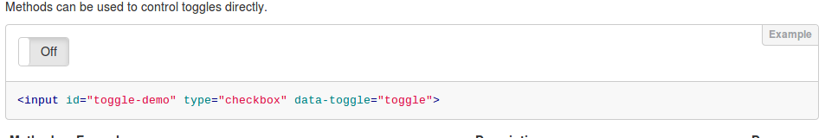
<input id="toggle-demo" type="checkbox" data-toggle="toggle">
Method | Example | Description | Demo
initialize | $('#toggle-demo').bootstrapToggle() | Initializes the toggle plugin with options
destroy | $('#toggle-demo').bootstrapToggle('destroy') | Destroys the toggle
on | $('#toggle-demo').bootstrapToggle('on') | Sets the toggle to 'On' state
off | $('#toggle-demo').bootstrapToggle('off') | Sets the toggle to 'Off' state
toggle | $('#toggle-demo').bootstrapToggle('toggle') | Toggles the state of the toggle
enable | $('#toggle-demo').bootstrapToggle('enable') | Enables the toggle
disable | $('#toggle-demo').bootstrapToggle('disable') | Disables the toggle

Events

Event Propagation
Note All events are propagated to and from input element to the toggle.
You should listen to events from the <input type="checkbox"> directly rather than look for custom events.
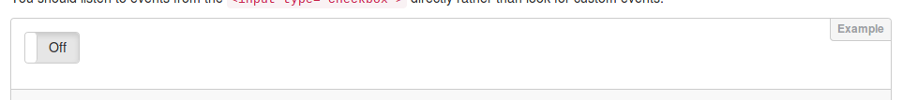
<input id="toggle-event" type="checkbox" data-toggle="toggle"> <div id="console-event"></div> <script> $(function() { $('#toggle-event').change(function() { $('#console-event').html('Toggle: ' + $(this).prop('checked')) }) }) </script>

API vs Input
This also means that using the API or Input to trigger events will work both ways.
<input id="toggle-trigger" type="checkbox" data-toggle="toggle"> <button class="btn btn-success" onclick="toggleOn()">On by API</button> <button class="btn btn-danger" onclick="toggleOff()">Off by API</button> <button class="btn btn-success" onclick="toggleOnByInput()">On by Input</button> <button class="btn btn-danger" onclick="toggleOffByInput()">Off by Input</button> <script> function toggleOn() { $('#toggle-trigger').bootstrapToggle('on') } function toggleOff() { $('#toggle-trigger').bootstrapToggle('off') } function toggleOnByInput() { $('#toggle-trigger').prop('checked', true).change() } function toggleOffByInput() { $('#toggle-trigger').prop('checked', false).change() } </script>

Demos

Sizes
Bootstrap toggle is available in different sizes. Refer to Bootstrap Button Sizes documentation for more information.
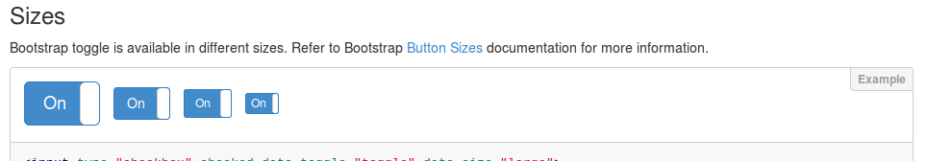
<input type="checkbox" checked data-toggle="toggle" data-size="large"> <input type="checkbox" checked data-toggle="toggle" data-size="normal"> <input type="checkbox" checked data-toggle="toggle" data-size="small"> <input type="checkbox" checked data-toggle="toggle" data-size="mini">

Custom Sizes
Bootstrap toggle can handle custom sizes by data-width and data-height options.
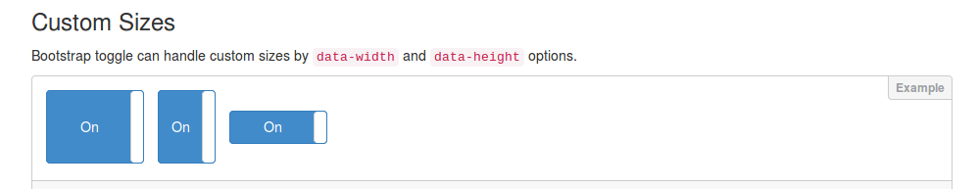
<input type="checkbox" checked data-toggle="toggle" data-width="100" data-height="75"> <input type="checkbox" checked data-toggle="toggle" data-height="75"> <input type="checkbox" checked data-toggle="toggle" data-width="100">

Colors
Bootstrap Toggle supports various colors. Refer to Bootstrap Button Options documentation for more information.

<input type="checkbox" checked data-toggle="toggle" data-onstyle="primary"> <input type="checkbox" checked data-toggle="toggle" data-onstyle="success"> <input type="checkbox" checked data-toggle="toggle" data-onstyle="info"> <input type="checkbox" checked data-toggle="toggle" data-onstyle="warning"> <input type="checkbox" checked data-toggle="toggle" data-onstyle="danger"> <input type="checkbox" checked data-toggle="toggle" data-onstyle="default">

Colors Mix
You can style on state as well as the off state.
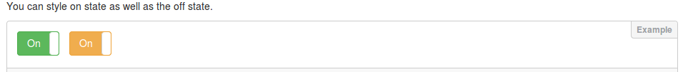
<input type="checkbox" checked data-toggle="toggle" data-onstyle="success" data-offstyle="danger"> <input type="checkbox" checked data-toggle="toggle" data-onstyle="warning" data-offstyle="info">

Custom Style
Customized styles can be applied as easily.
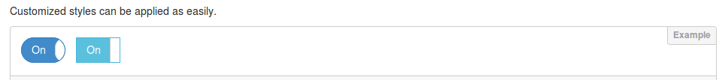
<style> .toggle.ios, .toggle-on.ios, .toggle-off.ios { border-radius: 20px; } .toggle.ios .toggle-handle { border-radius: 20px; } </style> <input type="checkbox" checked data-toggle="toggle" data-style="ios"> <style> .toggle.android { border-radius: 0px;} .toggle.android .toggle-handle { border-radius: 0px; } </style> <input type="checkbox" checked data-toggle="toggle" data-style="android" data-onstyle="info">

Custom Text
The text can be changed easily with attributes or options.
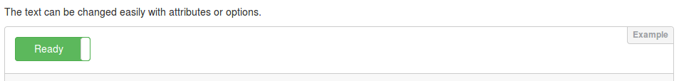
<input type="checkbox" checked data-toggle="toggle" data-on="Ready" data-off="Not Ready" data-onstyle="success" data-offstyle="danger">

Icons/Html Text
You can easily add icons or images since html is supported for on/off text.
<input type="checkbox" checked data-toggle="toggle" data-on="<i class='fa fa-play'></i> Play" data-off="<i class='fa fa-pause'></i> Pause">

Multiple Lines of Text
Toggles with multiple lines will adjust its heights.

<input type="checkbox" checked data-toggle="toggle" data-on="Hello<br>World" data-off="Goodbye<br>World">

Animation Speed
Transition speed can be easily controlled with css transition property on .toggle-group. You can also turn animation off completely.
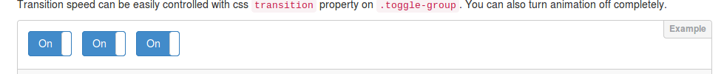
<style> .slow .toggle-group { transition: left 0.7s; -webkit-transition: left 0.7s; } .fast .toggle-group { transition: left 0.1s; -webkit-transition: left 0.1s; } .quick .toggle-group { transition: none; -webkit-transition: none; } </style> <input type="checkbox" checked data-toggle="toggle" data-style="slow"> <input type="checkbox" checked data-toggle="toggle" data-class="fast"> <input type="checkbox" checked data-toggle="toggle" data-style="quick">

Designed and built by Min Hur for The New York Times Company
Latest Version: 2.2.0 | Code licensed under MIT

